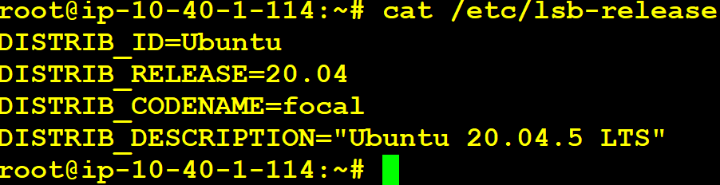

Current Jenkins Version:





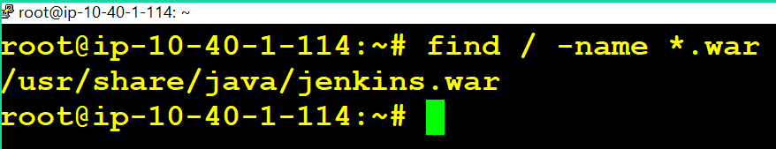

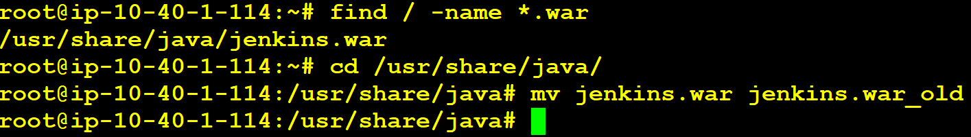

Find latest release from the following github repo:

<https://github.com/jenkinsci/jenkins/releases>

https://github.com/jenkinsci/jenkins/releases/tag/jenkins-2.401.3

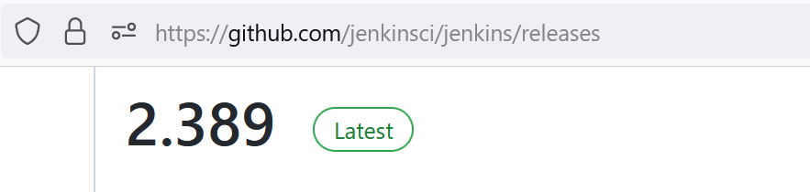

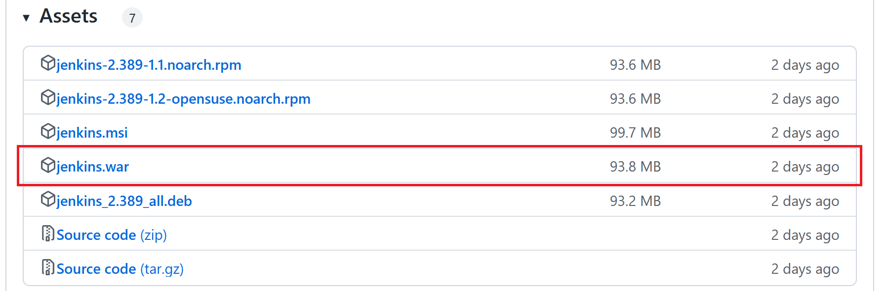

sudo systemctl stop jenkins

netstat -nltp #To check, jenkins is working on TCP/8080 or TCP/443.

cd /usr/share/java

mv jenkins.war jenkins.war_old

Download the WAR fine to location /usr/share/java

root@ip-10-40-1-114:/usr/share/java# wget <https://github.com/jenkinsci/jenkins/releases/download/jenkins-2.451/jenkins.war>

sudo systemctl daemon-reload

sudo systemctl start jenkins

sudo systemctl status jenkins



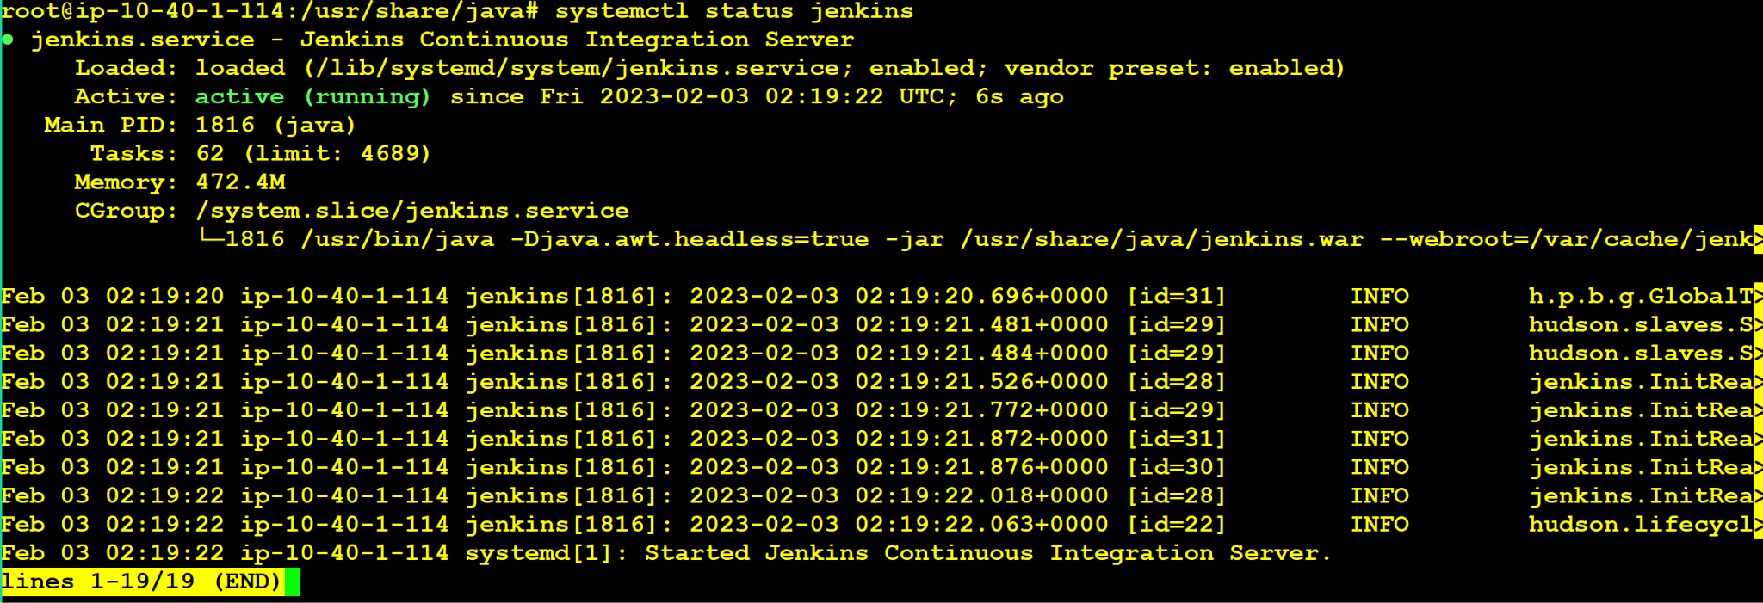

We can also check the jenkins version from the footer of the webpage.



TO



